**Angular HTTP Interceptors:**

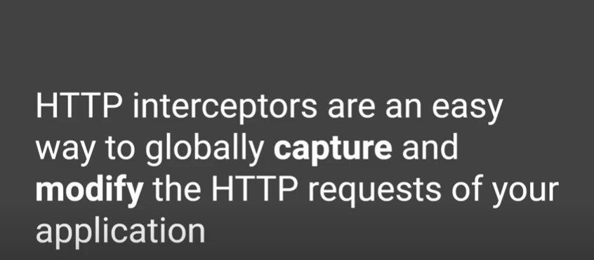

**If we think of our application as a client server application,**

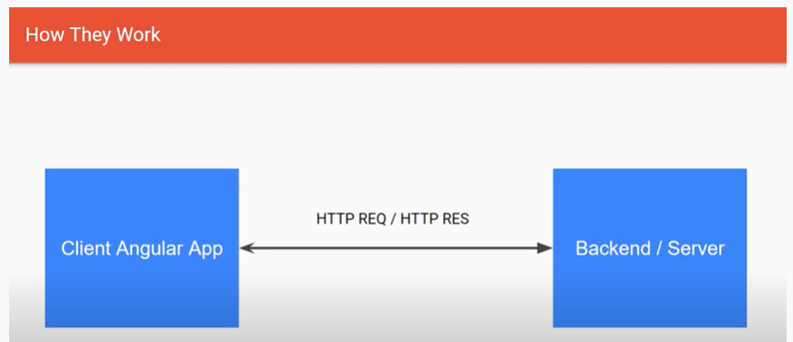

**We can inject Angular HTTP Interceptor as,**

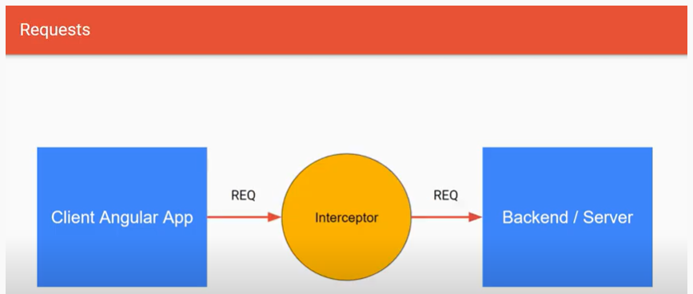

**What might be the use,**

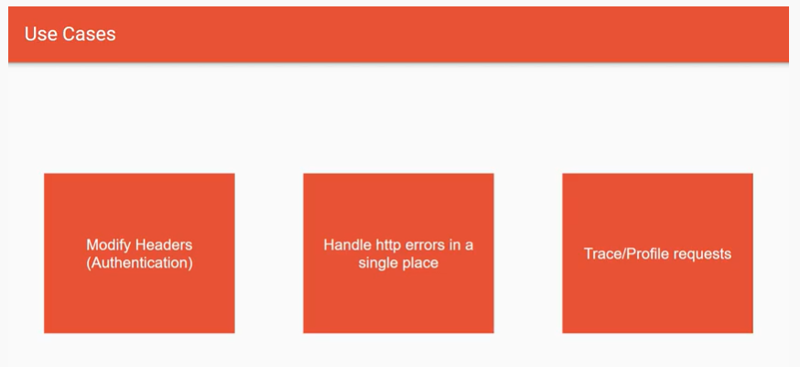

**Central Location for Handling Errors,**

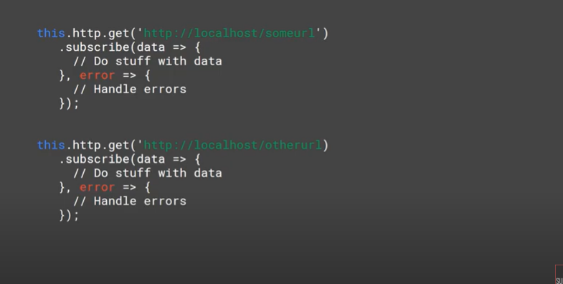

**Steps:**

1. **In app.component.ts**

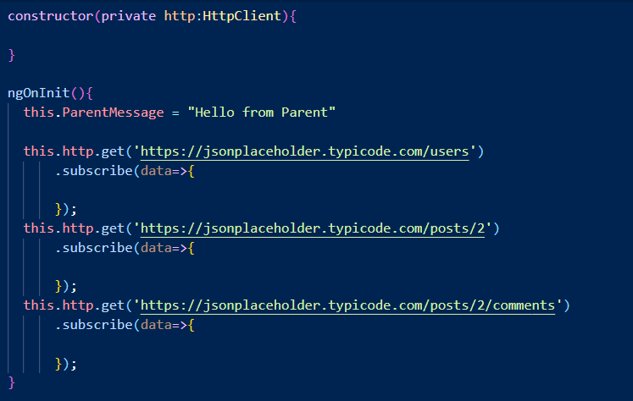

**2.**

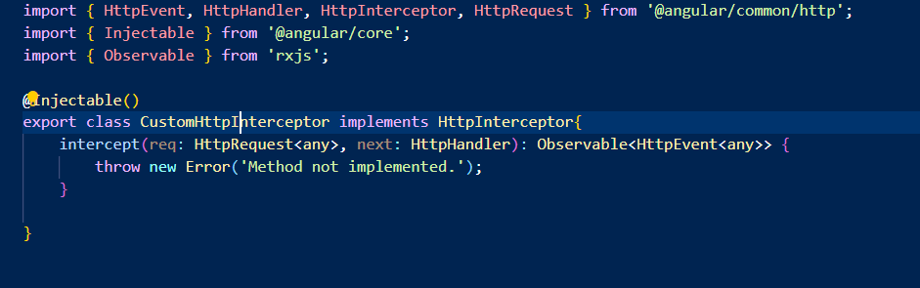

**3. Implement the class**

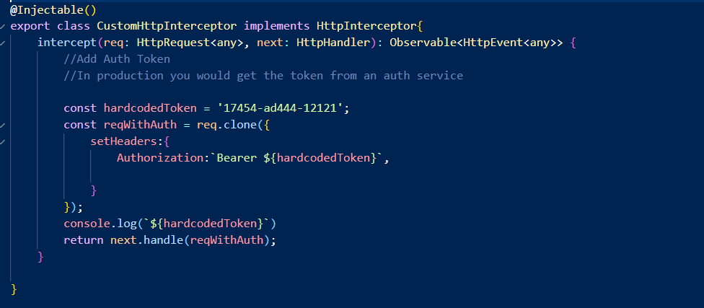

**4. Make the app.module.ts entries,**

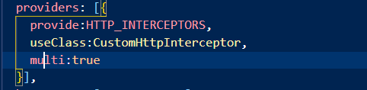

**5. Run the app, and we should see the hard coded token,**

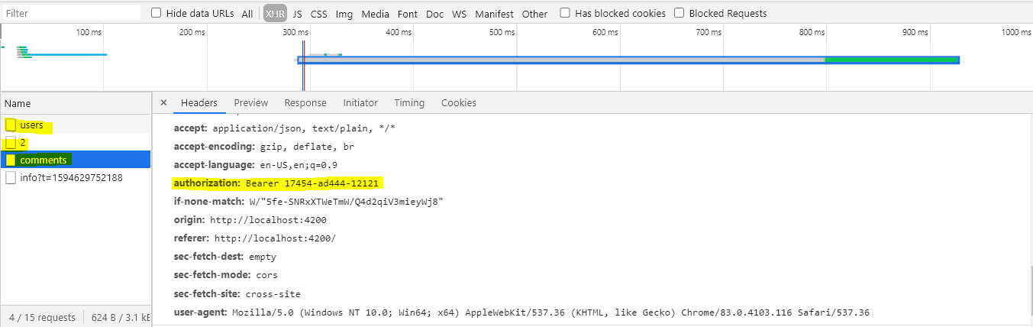

**6.Now lets implement a global error handler,**

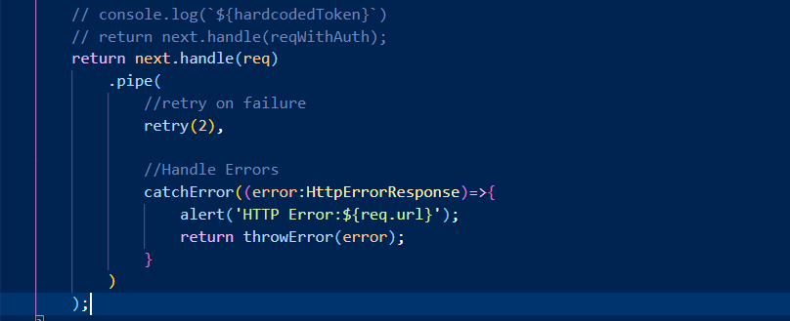

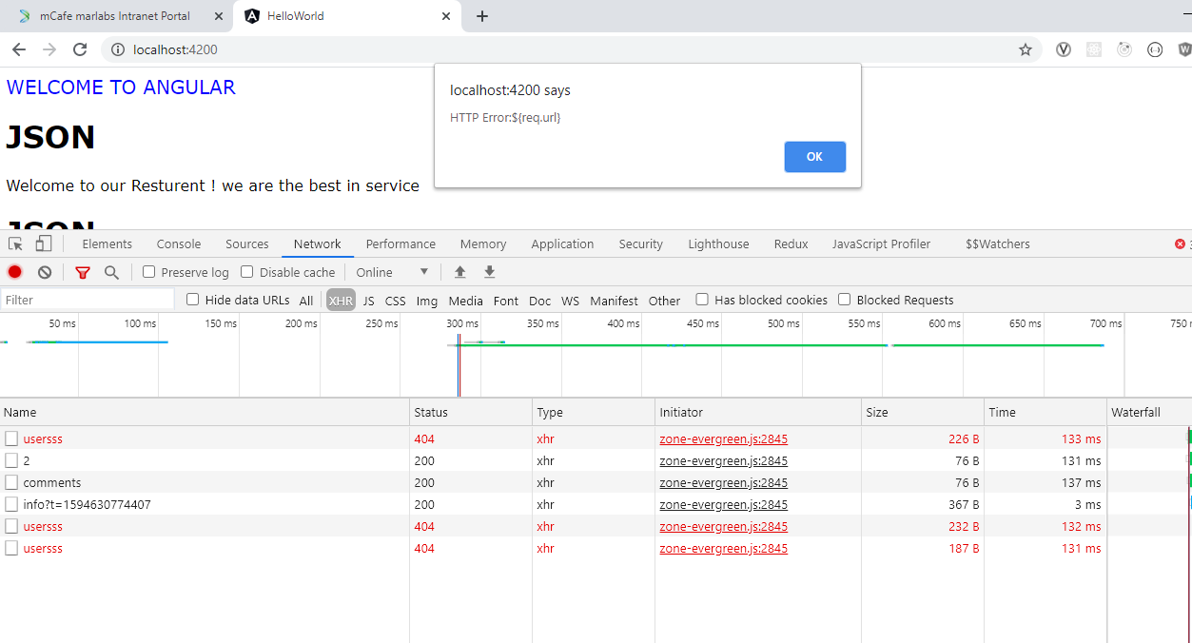

**7. Finalize**

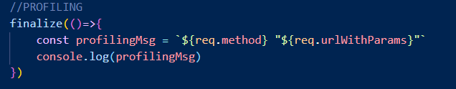

**8. Misc Imports,**

